
Using Free Audacity Voice-Recording Software for iBT Practice
CATESOL 2007 State Conference in San Diego
April 13, 2007
Presented by: Elena Payne-Wiens (epaynewi@uci.edu )
Dana Saito-Stehberger (esl@danasaito.de)

AGENDA

- What is the iBT?

- Description of the six iBT speaking tasks

- Audacity: Open Source voice recording software

- Practice iBT tasks using Audacity

For a digital copy of this packet and for iBT student self-evaluation handouts,
go to http://www.danasaito.de/pages/teachers.htm

Other resources
Audacity. (2006). Retrieved April 8, 2006, from http://audacity.sourceforge.net/

Beaumont, J. (2006). North Star: Building skills for the TOEFL iBT. New York: Pearson Longman. (This series has student and teacher books for intermediate, high-intermediate, and advanced levels.)

ETS. (2007). TOEFL iBT Overview. Retrieved April 5, 2007, from www.ets.org/toefl/nextgen (See handout for more ETS resources.)

Phillips, D. (2005). Preparation course for the iBT. New York: Longman. (Audio CDs must be purchased separately.)

Rogers, B. (2007). The complete guide to the TOEFL test. Boston: Thomson.

Related presentations here at the CATESOL 2007 Conference

“The TOEFL iBT intergrated tasks: Blazing the trail”
Presented by:
Marcia Armstrong and Gail West
Saturday, April 14 at 10:30-11:15 am
Room: Royal Palm Six (76)
“Authentic assessment through computer recording software”
Presented by:
Jee-Eun Oh and Roger Dupuy
Friday, April 13 at 4:30-5:14
Room: Terrace Salon Two (40)

Strategies for the iBT Speaking Tasks

Speaking Task | In order to do well on this task, you need to:
#1  Free-choice response | - Give descriptions of people, places, and things that you are familiar with  - Narrate an event or action  - Express your preference and support it with reasons and examples  - Quickly decide on an answer and think of supporting information  - Produce intelligible speech (using stress, intonation, and pauses to convey meaning)
#2  Paired-choice response | - Express your opinion and provide reasons and examples that support your opinion  - Make recommendations and defend your recommendations  - Take a position and provide justifications for it  - Produce intelligible speech (using stress, intonation, and pauses to convey meaning)
#3-4  Reading/  Listening/  Speaking  about a campus situation and an academic lecture | - Take brief but accurate notes on the reading passage  - Take brief but accurate notes on the conversation/lecture  - Read the question carefully and make sure you understand what it is asking you to do  - Plan your response using your notes and a simple outline  - Paraphrase and summarize the information in the reading and/or in the conversations/lectures  - Use the “language of citation” (ex. “According to the article . . . “; “The lecturer says . . . “) to indicate when an idea comes from a reading or a lecture.  - Explain the relationship between the information in the reading and that in the lecture.  - The integrated questions ask you to explain what you learn from the readings and/or the lectures, and to give reasons for the response. In other words, you need to integrate both the key ideas and the important examples or details from the material you read and/or listen to.  - Use transition words and phrases to separate the parts of your responses.
#5-6  Listening/  Speaking  about a campus situation and an academic lecture | - Take brief but accurate notes on the conversation/lecture  - Read the question carefully and make sure you understand what it is asking you to do  - Plan your response using your notes and a simple outline  - Paraphrase and summarize the information in the conversation/lecture  - Begin your answer with the “language of citation” (ex. “The student says . . .” / “According to the lecture . . . “.)  - The question about the campus conversation will ask you to explain what you understood from the conversation AND to give your opinion, so don’t forget to express your own point of view.  - The question about the lecture will ask you to summarize the main points of the lecture and explain what you understood.  - Use transition words and phrases to organize your response (first, second, so, as a result, because, however, etc.)

Using Audacity to Record Your Voice

You will need to have a headset with a microphone. Make sure that the switch on the cord of your headset is not on “mute”.

1. Go to “Start”, then to “Programs”. Click on the Audacity. The icon looks like this:  Your screen should then look like the following:

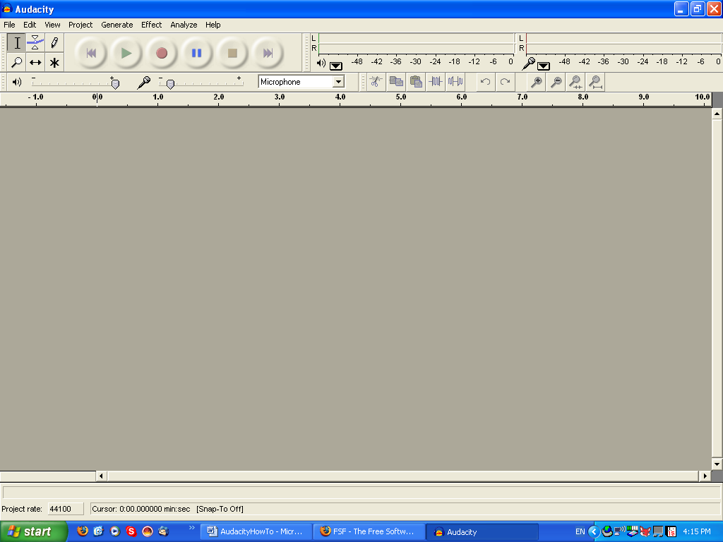

2. Press the RED CIRCLE (recording button) and Audacity will immediately begin recording.

3. Press the YELLOW SQUARE (stop button) when you are finished recording.

4. Press the GREEN ARROW (play button) to listen to your recording.
- If you are not happy with your recording and would like to start over, go to
File → New.

5. To save your recording,
  - Make sure you only have ONE recording open. If you save with multiple recording lines open, you will mix your recordings together.
  - go to File – Export as MP3
  - When you see the box that asks about format, click Okay (do NOT click Cancel – the recording will not save properly

Example iBT Speaking Assignment: Transcription of students’ recorded response

Name:

DUE: _________________________. You will turn in this sheet as well as your transcript.

- Listen to your recording.

- Write out what you said on a piece of paper, or type it out on a computer.

  - SKIP LINES (or double-space_
  - Be sure to include your mistakes AND pauses.

- Correct your mistakes with a different colored pen.

- Look at the scoring guide on green paper. What score would you give yourself? ________ Give reasons.

5. Answer the following questions.

- I read the question carefully | YES NO
- I used careful planning to outline my response. | YES NO
- I began with the overall topic statement. | YES NO
- I used strong supporting ideas. | YES NO
- I used transitions to connect the supporting ideas. | YES NO

  - What did you do well?

  - What would you like to improve on?

Example Assessment Guides of Speaking Tasks

Assessment of Tasks 1 & 2
Student: __________________________

Did you transcribe your 2 answers properly? YES NO
4 3 2 1

Did you correct your grammar & vocabulary errors? YES NO
4 3 2 1

Did you answer the question fully? YES NO
4 3 2 1

Did you have at least 2 reasons/examples to support your answer? YES NO
4 3 2 1

Did you use transitions? YES NO
4 3 2 1

Score: _________/20

Assessment of Tasks 3 & 4: Read, Listen, and Speak
Student: __________________________

Did you transcribe your 2 answers properly? YES NO
4 3 2 1

Did you correct your grammar & vocabulary errors? YES NO
4 3 2 1

Did you answer the questions fully? YES NO
4 3 2 1

Did you summarize the situation/information accurately? YES NO
4 3 2 1

Did you use “citation language”? YES NO
The reading passage was about… 4 3 2 1
The conversation/lecture was about…

Score: _________/20

